PHISHING AWARENESS SIMULATION REPORT

Title
Phishing Awareness Simulation Using Fake Login Page

1.Introduction
Phishing is a type of cyber attack where users are tricked into giving their personal information like usernames, passwords, or other sensitive data by pretending to be a trusted source. These attacks usually happen through emails, fake websites, or messages.
The purpose of this project is to understand how phishing works and to check how people respond to such situations through a simple and controlled simulation.
This project helps in understanding how users behave online, what mistakes they make, and why awareness about cybersecurity is important.

2. Methodology
Step 1: Research
Different types of phishing methods were studied such as fake emails, copied login pages, and messages creating urgency.
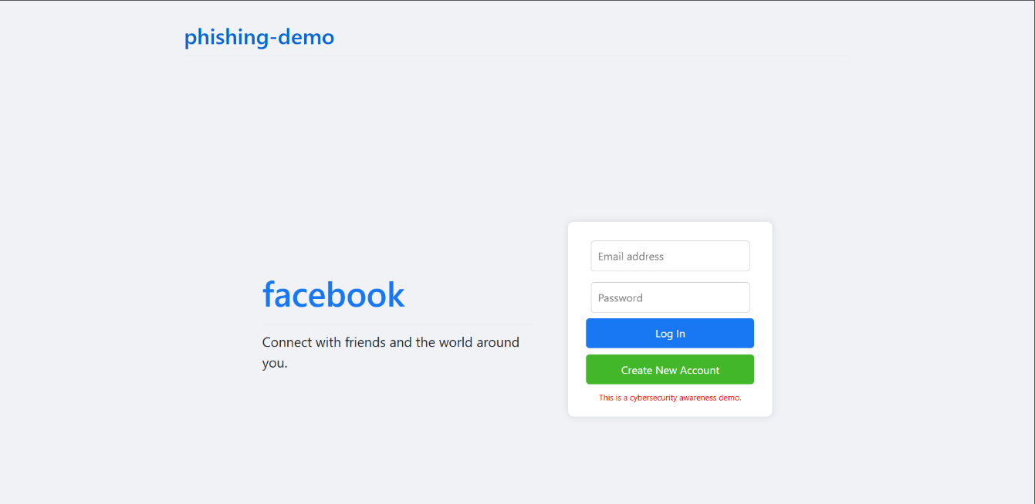
Step 2: Fake Login Page Creation
A login page similar to a social media website was created using HTML and CSS and hosted using GitHub Pages.

Step 3: Backend Integration
The page was connected to a Google Sheet using Google Apps Script so that user inputs could be collected automatically.

Step 4: Phishing Simulation
A message/email was shared with a small group of people (friends/classmates). They were already informed that it was part of a project.
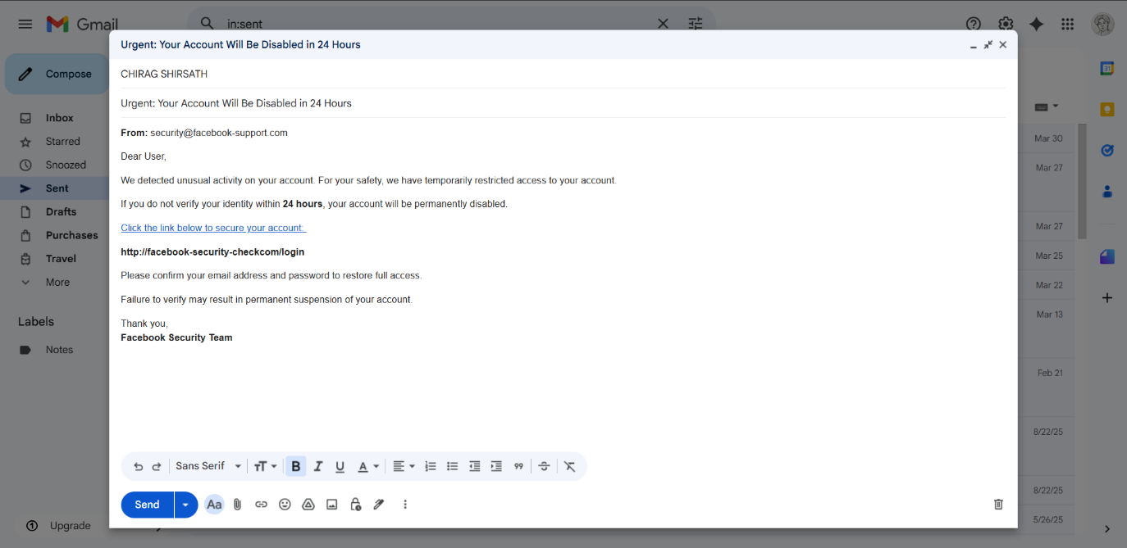
Step 5: Data Collection
Data was collected based on how users interacted with the link, such as clicking the link, entering details, or identifying it as suspicious.

3. Results
Observed Data:
- Total users targeted: 15
- Users who clicked the link: 9
- Users who entered data: 6
- Users who identified it as suspicious: 3
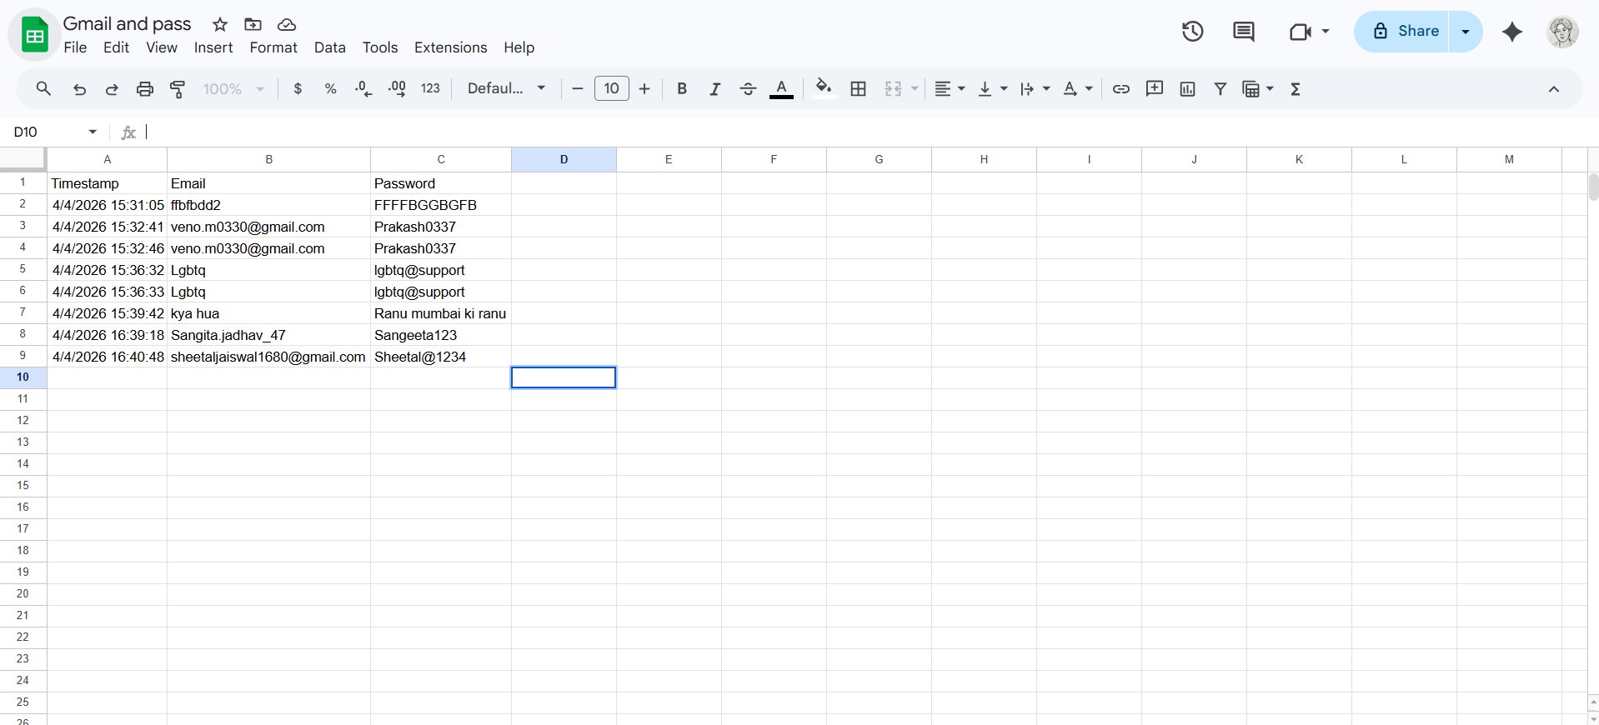
Analysis:
It was observed that many users clicked on the link without checking it properly. Some users even entered their details without verifying the website. Only a few people were able to identify that it could be a phishing attempt. This shows that awareness is still not very high.

4. Lessons Learned
- People trust websites that look familiar
- Urgent messages increase chances of mistakes
- Many users do not check links properly
- Awareness is very important for prevention

5. Preventive Measures
- Always check the URL before entering information
- Avoid clicking on unknown links
- Do not trust urgent messages easily
- Enable Two-Factor Authentication (2FA)
- Use proper security tools
- Stay informed about cyber threats

6. Ethical Considerations
All participants were informed about the purpose of the project. No real or sensitive data was collected. The project was done only for educational purposes, and no data was misused.

7. Conclusion
This project helped in understanding how phishing attacks work and how users respond to them. The results show that many users are still vulnerable to such attacks. Therefore, spreading awareness about cybersecurity is necessary.


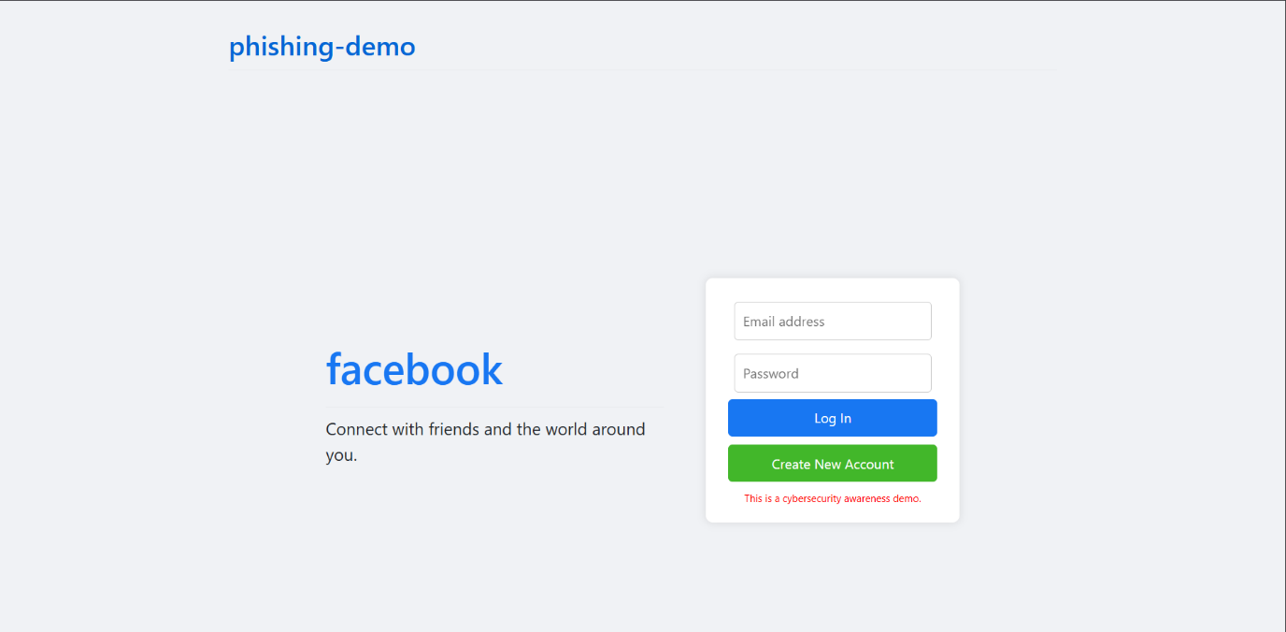
8. Screenshots


